

Board: Battery Board V3
Belongs to: Applications Engineering
Point of Contact: Josh Brown

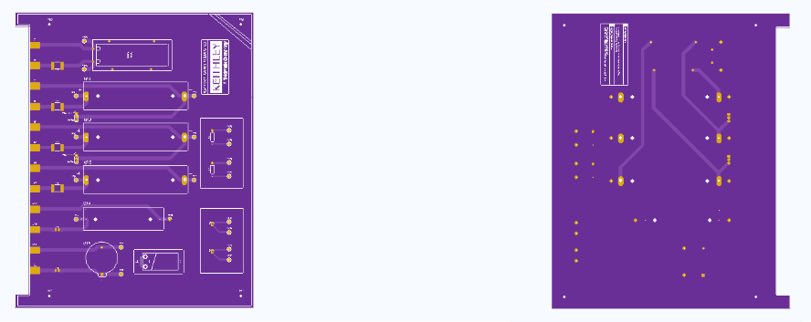
Components for each board (5 boards total):
- 18650 Battery Holders (x3)
- AA Battery Holder (x1)
- 20.0 mm Coin Cell Battery Holder (x1)
- Red Banana Jacks (x6)
- Black Banana Jacks (x6)
- Red Test Points (x10)
- Black Test Points (x10)
- 3-pin Headers (x2)
- 10k NTC Thermistors (x2)
- PTC Reset Fuse 6V 0.5 A 0805 (x2) (or 6V 1.25 A if prepping for pulse testing)
- PTC Reset Fuse 24V 2 A 2920 (x4) (or 24V 7 A 2920 if prepping for pulse testing)
- Anmbest 3S 11.1V/12V/12.6V 10A 18650 Charger PCB BMS (x1)
- Square Bumper Feet (x4)
Soldering and Assembly Instructions:
- Solder the 6 fuses: 0805 (x2) and 2920 (x4) to the SMD terminals near the banana jack inputs (left side of the board based on the orientation above).
- Solder the 10k NTC thermistors to the 2 SMD part pads in the lower right corner of the board (based on the orientation above).
- Solder all 20 test points to the board (Red to positive traces, black to negative traces)
- Solder banana connectors to the board (Red to positive traces, black to negative traces)
- Solder 3-pin headers to the board
- Solder wires to each terminal on the BMS
- Secure the BMS to the board via Velcro (or additional methods if desired)
- Solder the other end of the wire directly into the corresponding pad on the board
- (Optional) Mount the board to surface using M2.5 mounting holes in the 4 corners of the board
- Elevate the board using rubber/plastic feet
Congrats! The board is ready to go! Insert desired batteries into the battery holders and begin testing.

